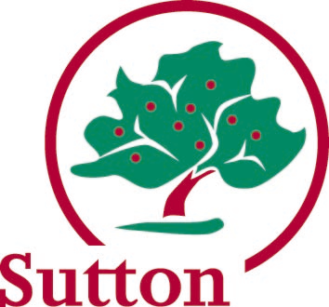 Guidance Health providers template

What is the Local Offer?
From September 2014 every Local Authority will be required to publish information
about services they expect to be available in their area for children and young people
from birth to 25 who have special educational needs and/or disabilities (SEND); and
also services outside of the area which they expect children and young people from
their area will use. This will be known as the ‘Local Offer’.

The Local Offer will put all the information about education, health and care services,
leisure activities and support groups in one place.

It has two main purposes:
- to provide clear, comprehensive and accessible information about the support
and opportunities that are available; and

- to make provision more responsive to local needs and aspirations.
Why is it important for my organisation?
Information is provided in lots of different ways already; the Local Offer aims to make
it simpler for parents to find, understand and use a vast range of information so it is
important that services of a similar type answer the same questions following the
order they are presented and keeping to the same format.

The questions were designed with parents/carers so you can be sure that your Local
Offer will answer the main questions that parents/carers will have about your service.

By providing the information that forms the Local Offer settings and services will:
- help communicate to parent carers, and others who work with the
organisation, how children and young people with SEND are supported

- provide a clear ‘profile’ of the individual organisation

- help to prevent misunderstandings which can sometimes make working
together difficult

- be co-producing the information with parent carers and children and young
people which will help develop strong partnerships and increase
understanding

- be an opportunity to review processes and ways of working together

Top Tips for presentation
Thinking about the wide audience who may want to access your Local Offer:
- Use short, ‘bite-size’ sentences or paragraphs to communicate the information

- Include direct links to other information sources where further detail/
investigation would be recommended, e.g. service referral form

- Avoid where possible the use of jargon, abbreviations or ‘professional speak’;
use plain English

- To ensure the Offer is clear ask an independent person to proof read the final
version of the Offer (preferably a parent or carer) before uploading to the website

