Adult Social Services

Fairer Contributions Policy


Public Discussions

July to September 2010



Fairer Contributions Policy
for non-residential services

A contribution is when you are asked to give money towards something, for example, a service.

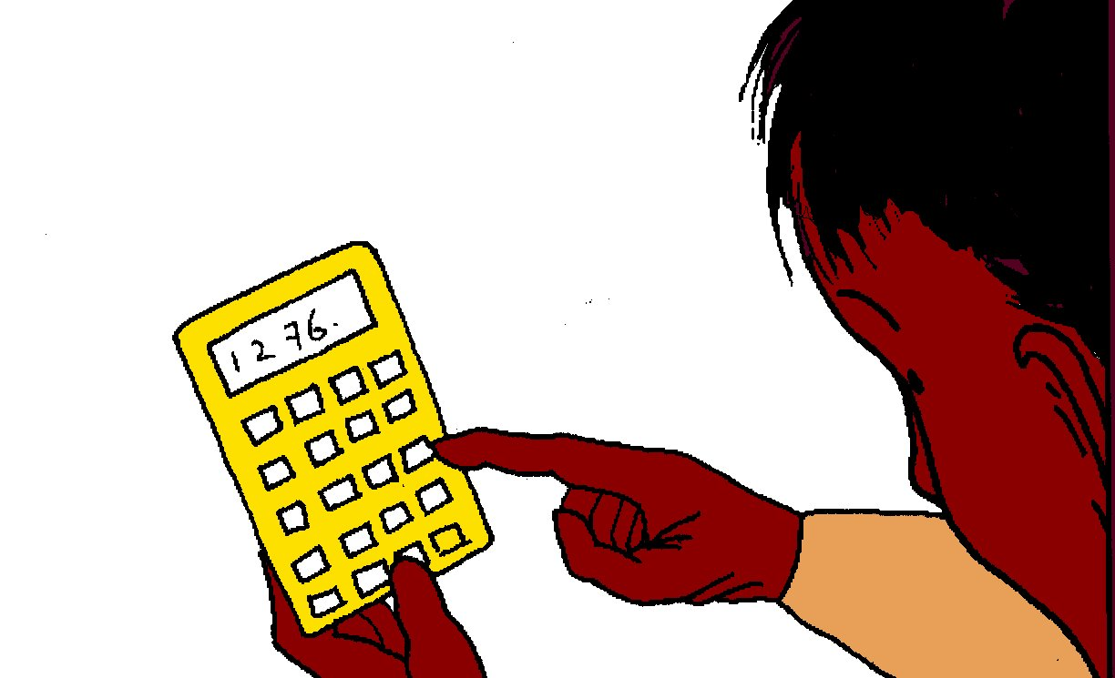
Sutton Council is asking people about its Fairer Contributions Policy for non-residential services. This policy will replace the current Fairer Charging policy. This booklet tells you about the Council’s plans, and says how the Council will work out people's contributions towards their Personal Budget.

In this booklet, a Personal Budget means money for you to buy your care and support.

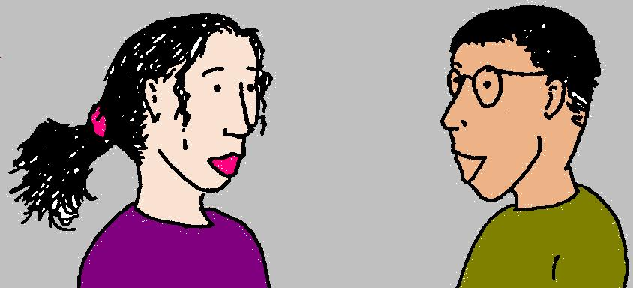
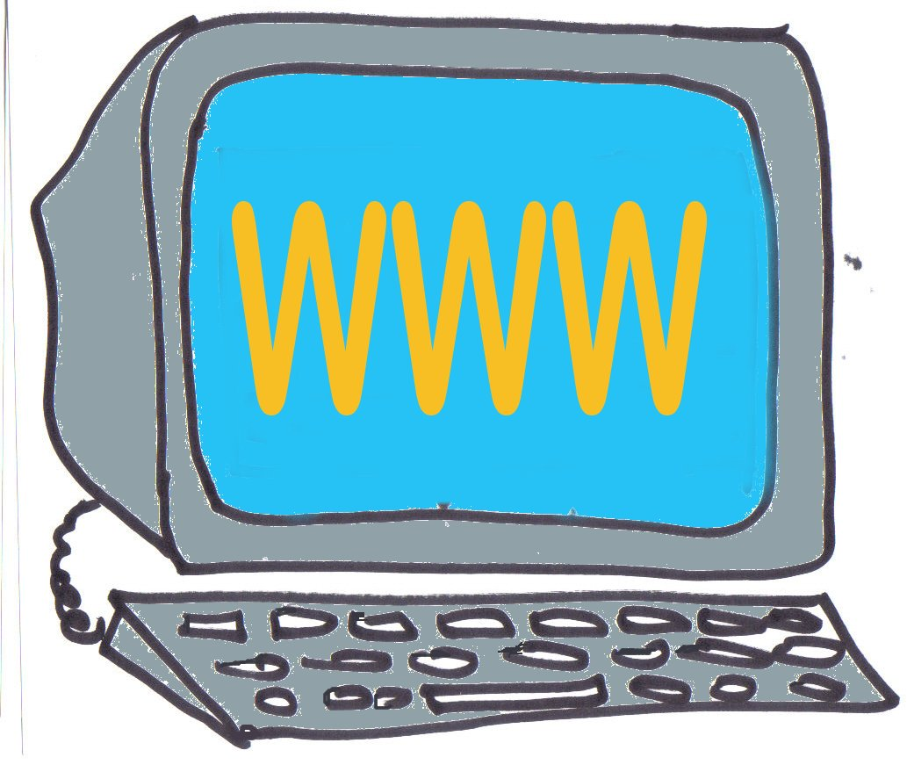

The Council wants to hear what you think about its ideas on the Fairer Contributions Policy. So it is speaking to the community in different ways: through meetings, telephone and the internet. This is to give people the best chance to share their ideas.
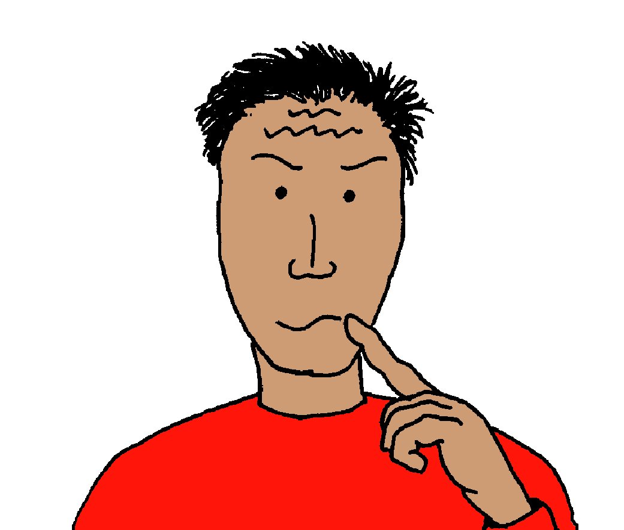
This booklet explains why we've had to change the policy, and answers some questions you might have about the new Contributions Policy.

It gives some examples of how Sutton Council's plans may make a difference to your contribution. It tells you how the Council will work out how much you will be asked to pay. Also, it will say how you can pay your contribution and how people can ask for their contribution to be reviewed.

Contents
Page
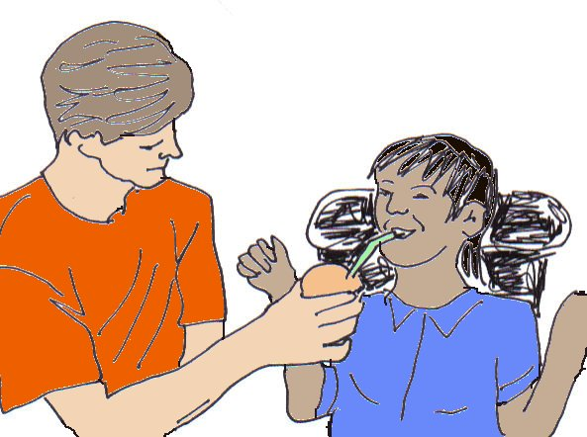
What is Personalised Care and
why is it being introduced? 5

How will Personal Budgets work? 7

Introduction to the Council's Fairer Contributions Policy 8

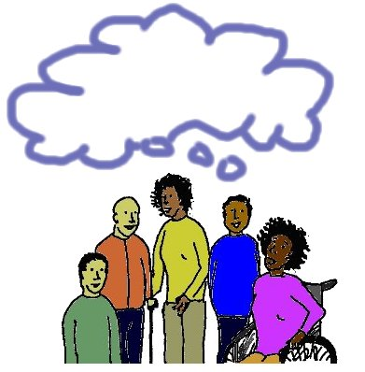
Ideas for the new Contributions
Policy that the Council
wants your views on 11


How you can take part
in the discussion 14

What is Personalised Care and
why is it being introduced?

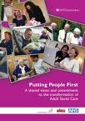
There is a national plan called Putting People First. This plan is to improve all adult social care services. It says that people themselves know their needs best and how they can be met.

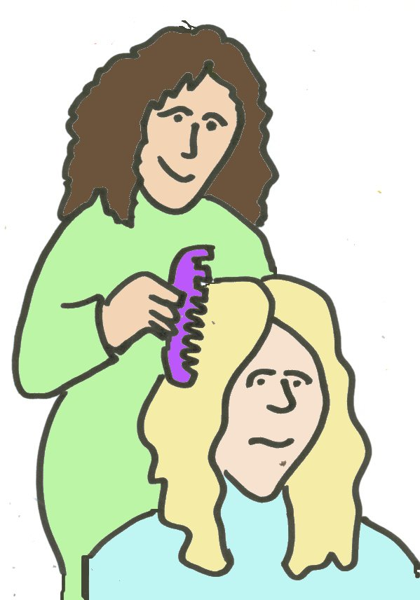
Personalised care is a new way of providing and paying for care services. Services can be made to suit each individual. People will have more control over their own care.

Anyone who can get adult social care will be given their own Personal Budget. They can use this to buy their own care and support from the Council, or other places like care agencies.
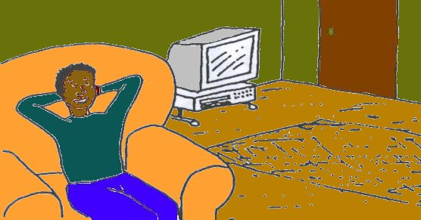
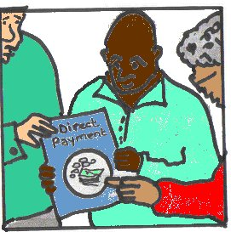
You could have your Personal Budget paid to you in cash as Direct Payments or as services provided by the Council. Or a care agency could look after your budget for you.



You can choose to have a mixed Personal Budget - some in cash and some in services provided by the Council.

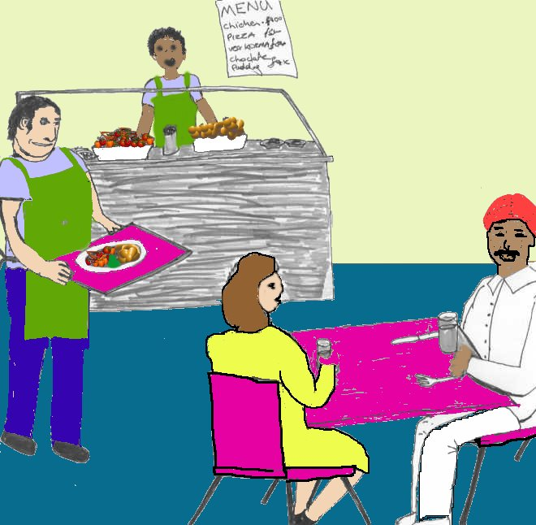
For example - instead of paying a care agency to help you in and out of bed, you can ask a friend to help you. Then when you go out with your friend you can use some of your budget to buy them a meal to say thanks.
How will Personal Budgets work?
People able to get care services paid for by the Council will:

- Get a Personal Budget to buy their own care and support

- Be able to arrange for care and support that best suits their needs and circumstances (there is help to arrange this)
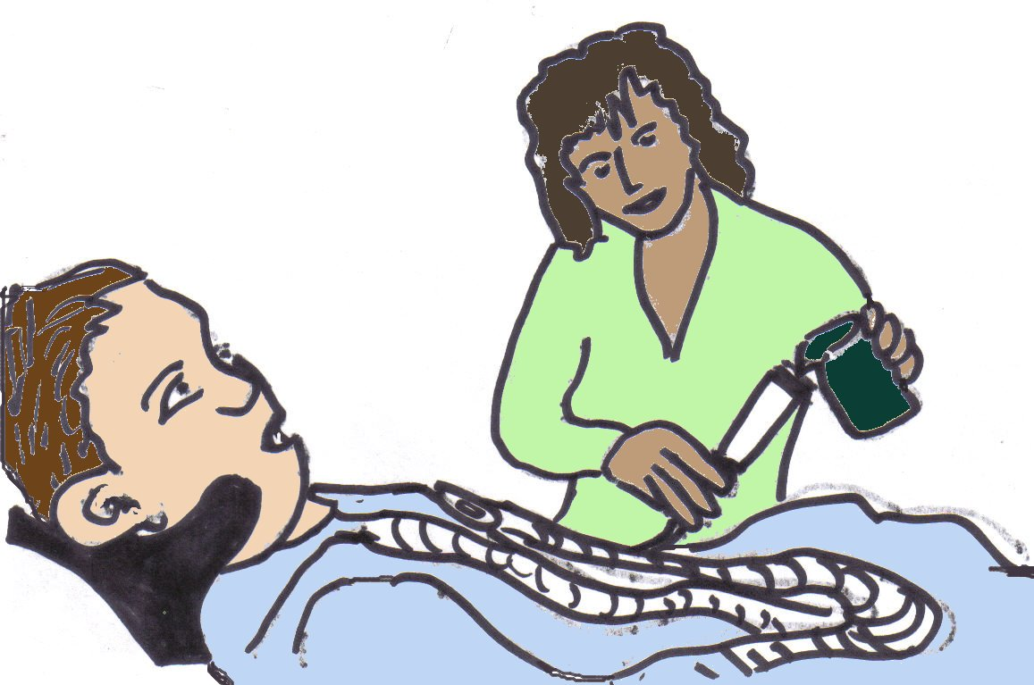
- Be able to control the type of support they get and how this is delivered

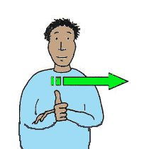
- Be able to say how services should be developed in the future

A person will only get a Personal Budget if they are allowed to get support paid for by the Council. If someone pays for all their own care, they will not get a Personal Budget. But they can still ask the Council for help to arrange their support.

If you want your Personal Budget paid in cash, it will be through a Direct Payment. As long as your needs, written in your care and support plan are being met, you can choose how your services are delivered and who provides them.
Introduction to the Council's
Fairer Contributions Policy

The current charging arrangements

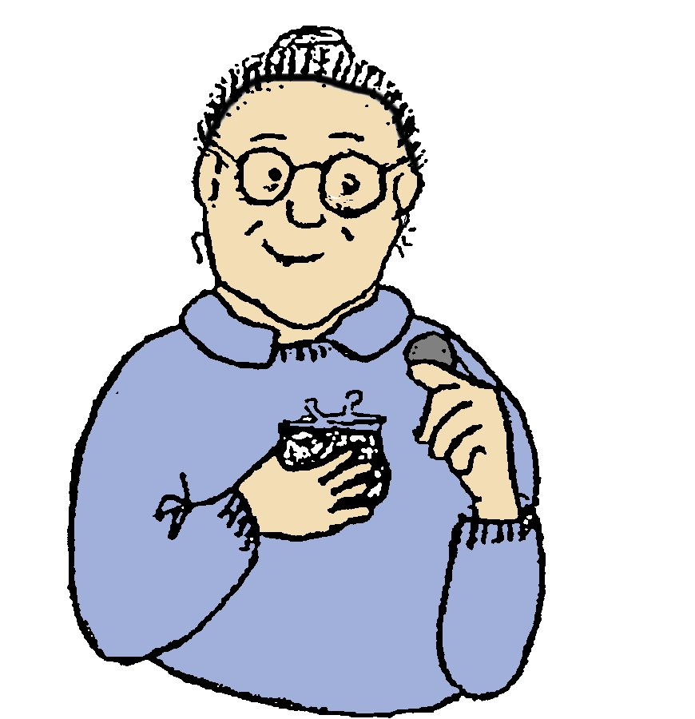
At the moment, Sutton Council charges for services and takes into account how much people can afford to pay. This system, like the new Fairer Contributions Policy, is based on ability to pay. The Council works out what someone can afford to pay towards the services they get. The Council charges an amount that is based on the type and amount of those services.


Charges for services may be less than the true cost of those services. Some services are subsidised, which means the charge is lower because part of the cost is paid by the Council. The new Fairer Contributions Policy will end these subsidies. Sutton Council needs to change the current system. This is because, with Personal Budgets, people's contributions have to be based on the amount of money in their Personal Budget not on the type and amount of services received.

Subsidise means to pay part of the cost of something.

What is Fairer Contributions about?


Sutton Council provides and arranges a wide range of Social Services and support for people who need assistance. The government expects Councils to collect money from those who can afford to contribute towards the cost of their care. The money collected helps to pay for services and support for those who need it.


'Fairer Charging Policies for Homecare and Other Non-Residential Services' and 'Fairer Contributions Guidance' are guides written by the Department of Health. They say that a Council’s Social Services charging policy must be fair, consistent and open.


With this in mind, Sutton Council has written its Fairer Contributions Policy which explains how contributions for service users will be worked out.


People who might use care will complete an Assessment (with help if need be). This will help to work out how much Personal Budget each individual will need to buy their care and support. People will be asked to pay a contribution towards the cost of their Personal Budget.
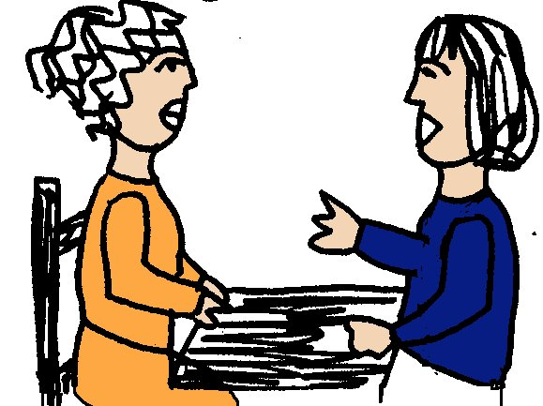
Not all services will be covered by a Personal Budget. Some will still be free, for example, advice and assessment. Some services like meals on wheels will have a fixed charge. Most types of support will be included in the Personal Budget, but you will be asked to contribute towards this, based on how much you can afford to pay.


Why are we making these changes?

- We need to make changes based on what the government says

- We need to keep getting money in so we can contribute to the cost of services. Otherwise we might have to cut back more on services

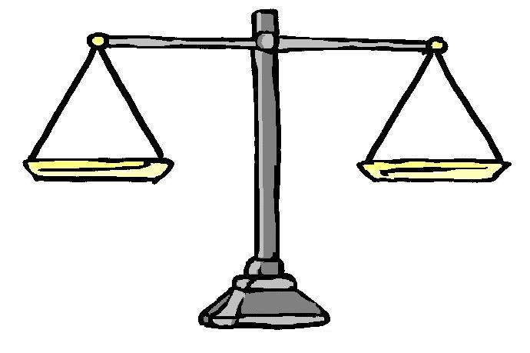
- We need to make sure that the system is fair so that people’s contributions don’t depend on the type of needs they have or the services they choose
Ideas for the new Contributions
Policy that the Council
wants your views on

What are the Council’s plans?

The Council would like your views on the following plans:

- At the moment, charges for some services do not cover their full cost. This means that it is subsidised, even if users are paying the maximum charge for the service. In future, we plan to charge against all of someone's Personal Budget, while making sure that they are able to pay. This means that those who can afford it will pay the full cost of the services they use. The weekly maximum charge of £360 will be stopped.

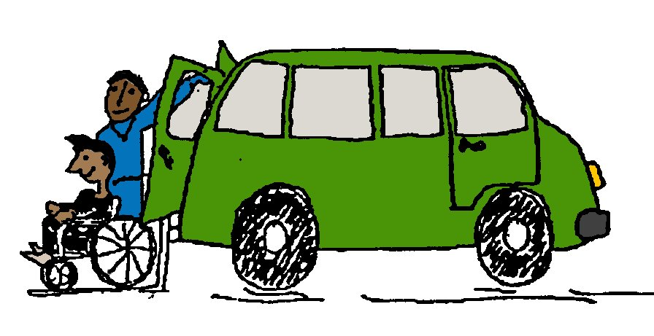
- Transport is not charged separately at the moment. This means that if someone does not need Council transport, they still pay the same as other people who do. We plan to include the cost of transport in the Personal Budget so that if someone uses it, they pay towards the cost, if they can afford to.
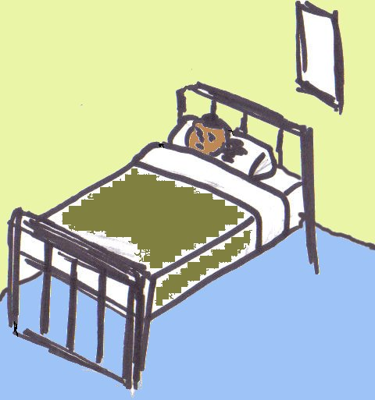
- Money to pay for respite care will be included in the Personal Budget, depending on how much care and support is needed. For people needing to have respite care in a residential care or nursing home, there is no plan to change the way respite care is paid for.

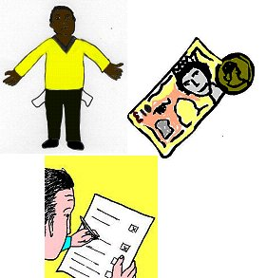
- When we work out how much people should pay, we already check to see that they are getting all their benefits. As part of the new policy, we will work this out again so that everyone will be up to date.

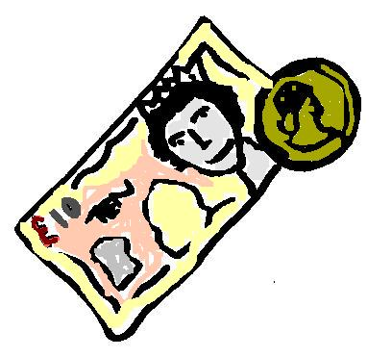
- Someone who does not want a cash budget, can ask the Council to carry on arranging care and support for them. They will have to pay a bill. Some people may want to have part of their Personal Budget as cash and the Council to provide the rest of their support.

- If you get all or some of your Personal Budget as a Direct payment, we will take off any contribution you have to pay before putting the money into your account. You should pay your contribution into your Direct Payment account. We will check that this has happened. If your contribution is more than the Direct Payment part of your Personal Budget you will have to pay a bill.

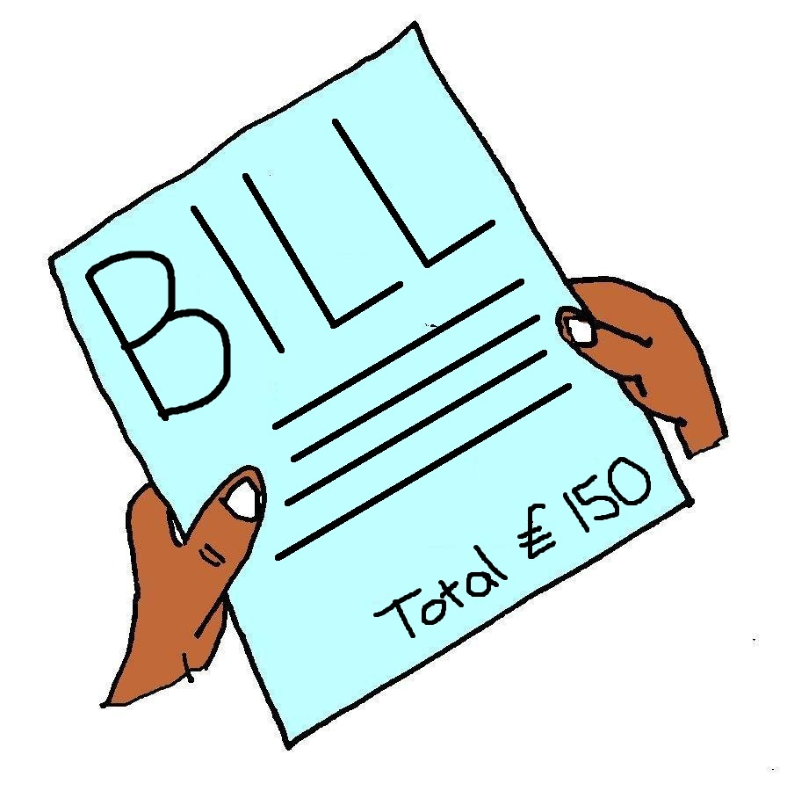
If possible, all of your contribution will be taken from the cash part of your Personal Budget. If this is not possible, you may still get bills for the rest. Where the contribution is very small we will send out the bills less often, but we will still expect people to pay.
NEW
OLD

- People who are already getting support from Adult Social Services will have some protection during the move to the new system.

We want to know if you agree that:
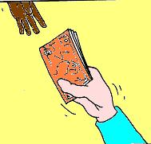
100%
People should pay the full cost of their care and support if they can. This could mean all of their Personal Budget.

Money to pay for transport should be included in the Personal Budget.

People with large savings should put them towards their care costs

Even if the amount someone has to pay is very small we should still collect it, but we would send out bills less often.
How you can take part
in the discussion

You can take part in the discussion in different ways.

You can fill in the questionnaire that came with this booklet and send it back in the envelope provided.

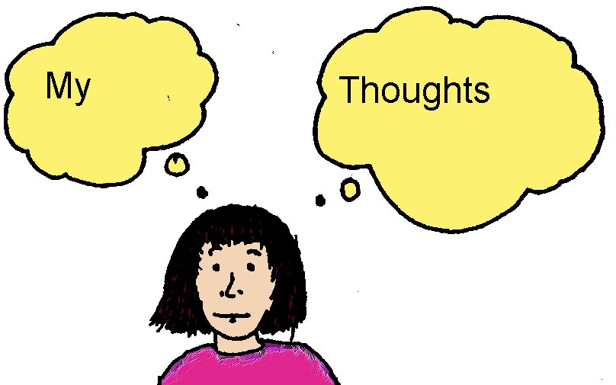
We have organised events to talk about this. The details are in the letter that came with this booklet. You are welcome to come along and tell us what you think.


Some of these events will be held in day care centres and sheltered housing schemes. This will make it easier for some people to take part.

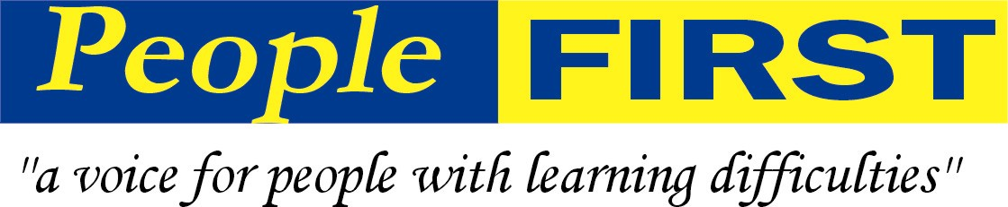
This document was put into Easy Read by:
www.peoplefirstltd.com

